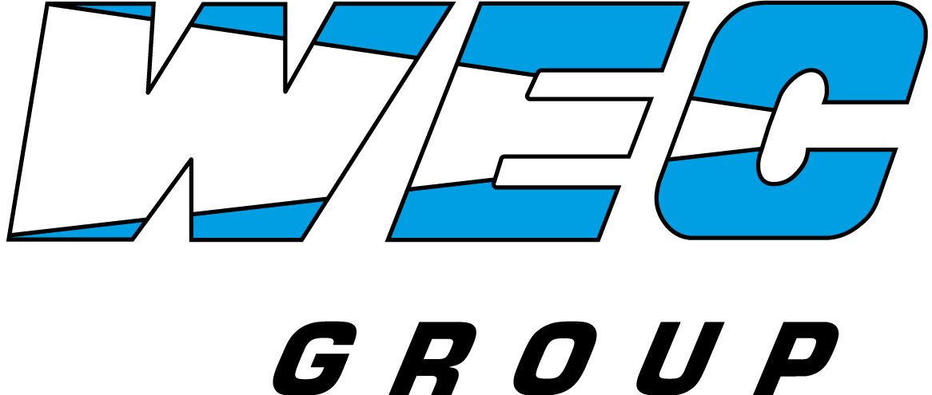

**For Immediate Release**

**WEC Group Acquires Laser Profiles Ltd, Setting Stage for Further Growth** **and Expanding Reach to the South of England**

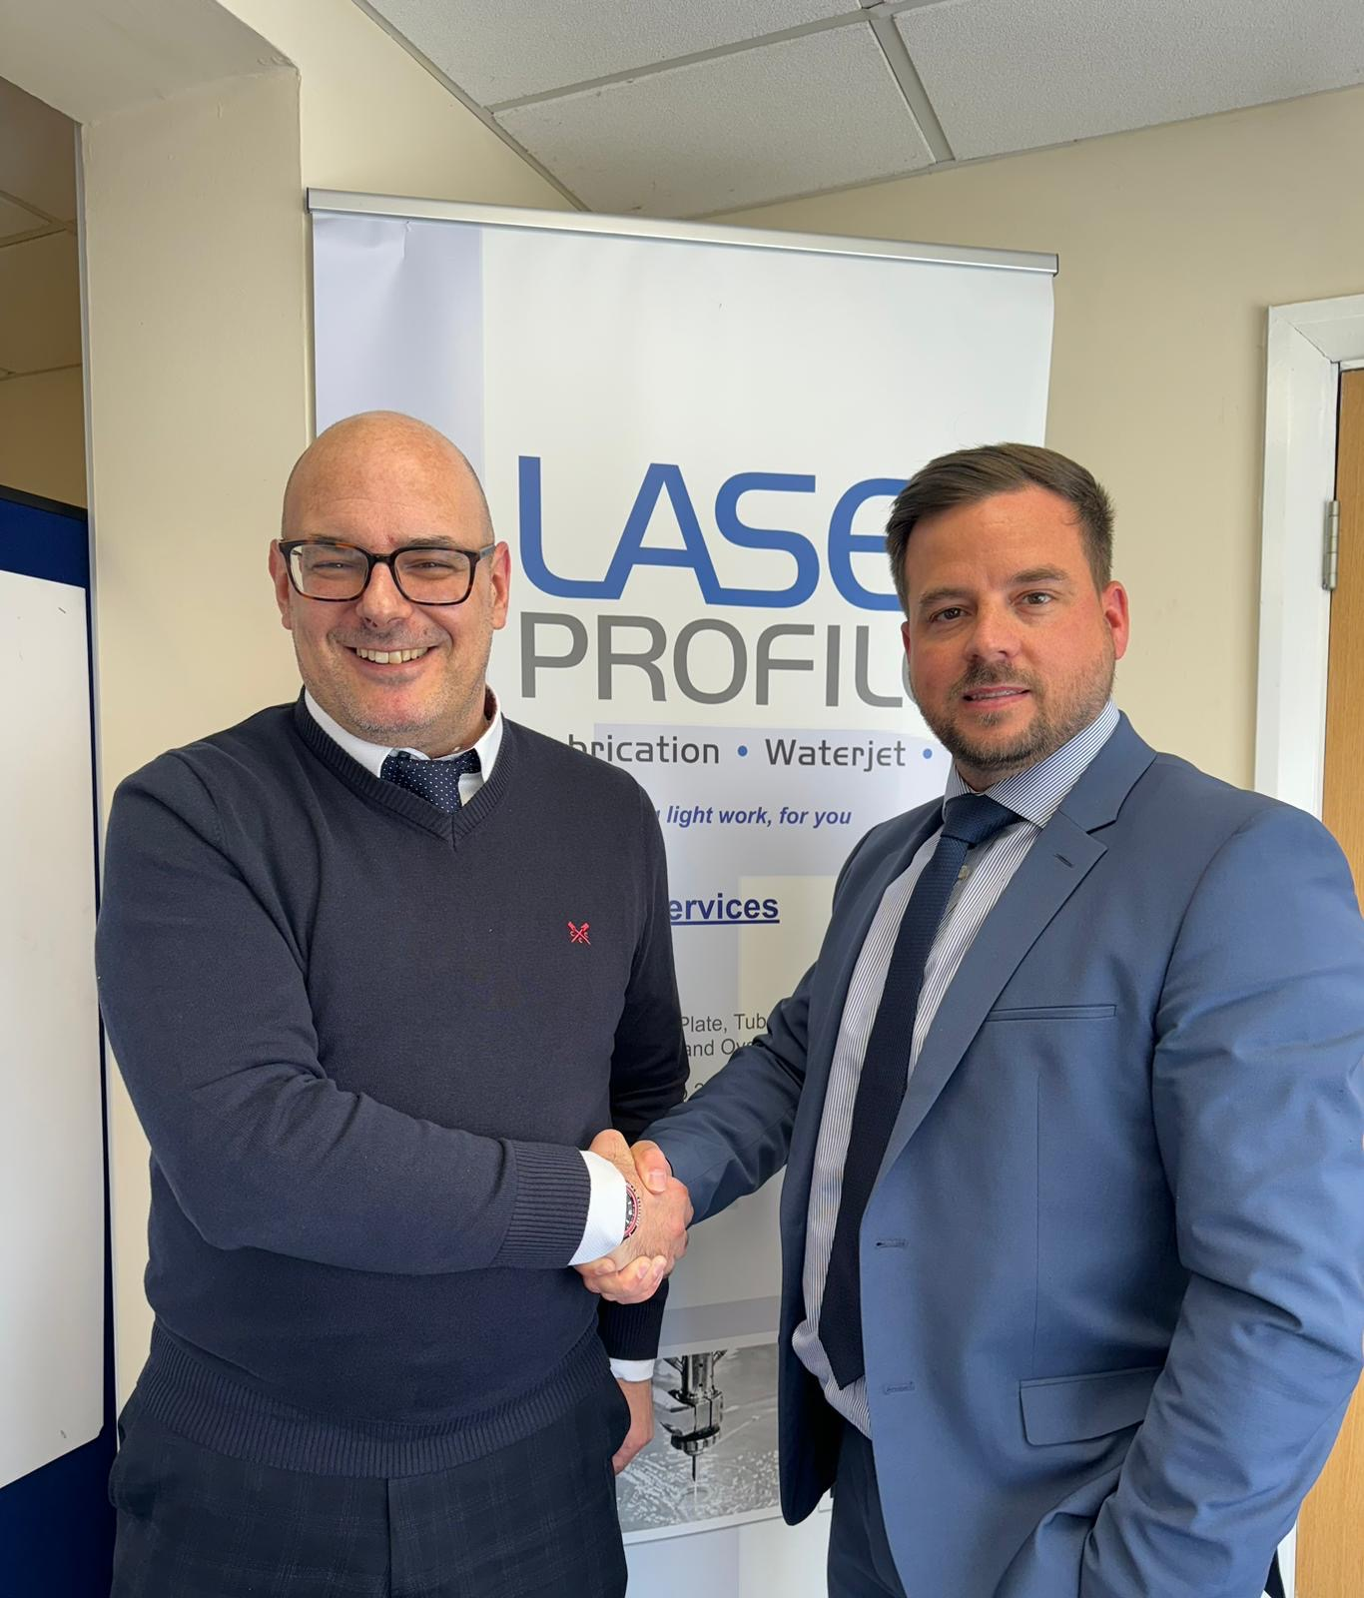

***Pictured: Mark D’Amico (left), General Manager at Laser Profiles Ltd and James Pickles (right), Service Centre Manager at WEC Group***

Dorset, UK – WEC Group, the UK’s largest fabrication and contract manufacturing company, is pleased to announce the strategic acquisition of Laser Profiles Ltd, a leader in precision laser cutting based near Bournemouth, Dorset. This acquisition is part of WEC Group’s long-term growth strategy to extend its reach across all corners of the UK and reinforce their market leading position in the contract manufacturing sector.

Trading for over 25 years, Laser Profiles Ltd has established itself as a leader in providing bespoke laser cutting and fabrication solutions to various key supply chains in the South of England. This new partnership is designed to leverage the unique strengths of both companies, optimising production capabilities and enhancing service offerings to clients across various industries.

Laser Profiles Ltd boast an impressive array of cutting-edge technology, including a fully automated state-of-the-art Trumpf fibre laser, which offers high-speed cutting with exceptional quality. They also operate an Adige fibre tube laser, enabling them to supply round tubes, box section, angle and channel profiles to their customer base. Additionally, their capabilities extend to a full suite of in-house fabrication services including precision sheet metalwork and welding.

By joining forces with WEC Group, who are already established as the UK’s largest metal profiling and fabrication company with 25 laser cutting machines, 23 press brakes, 3 waterjet cutting machines high-definition plasma cutting machines, as well as over 40 CNC Machines, 200 skilled welders, 13 robotic welding cells, and full in-house powder coating and wet painting capabilities, Laser Profiles will gain access to enhanced technological resources and a much broader market reach.

James Pickles, Service Centre Manager at WEC Group, commented on the acquisition: "The addition of Laser Profiles to the WEC Group represents another important milestone in our ongoing expansion plans, and as our first manufacturing site in the South of the UK, it will open the door to further growth as we gain access to new target markets. This acquisition allows us to harness synergies between our capabilities and expertise, enhancing our ability to serve our clients’ needs and further reducing manufacturing lead-times."

WEC Group has a history of successful integrations, with past acquisitions including MTL Advanced in Rotherham, South Yorkshire, HTA Group in Coventry, West Midlands, and 5750 Components in Knowsley, Merseyside to name but a few. Each acquisition has strategically expanded WEC’s capabilities and market reach, affirming its commitment to excellence in the UK manufacturing supply chain.

The integration of Laser Profiles Ltd will benefit all stakeholders, providing existing staff with opportunities for growth and advancement within a larger organisation, and offering customers a more comprehensive range of services under one roof. This will improve supply chain efficiencies and provide enhanced value to clients.

"We look forward to a smooth integration and are excited to start working together to achieve the benefits this acquisition is set to bring. Laser Profiles will effectively act as our gateway to the South, and we have very ambitious plans to scale the business in a substantial manner by using our industry expertise to bring it to new heights." added Mr Pickles.

[www.laserprofiles.co.uk](http://www.laserprofiles.co.uk)

[www.wec-group.com](http://www.wec-group.com)

ENDS____________________________________________________________________________

**About WEC Group**

WEC Group Ltd is a leading UK-based engineering and fabrication company, providing a wide range of services including CNC machining, laser cutting, waterjet cutting, and fabrication solutions to various industries. With 10 manufacturing sites in the UK, 900 staff, and over 40 years of experience, WEC Group continues to grow, driven by a commitment to quality and innovation.

WEC Group have recently a series of other substantial investments for 2024 including a £10m investment to build Europe’s largest subcontract heavy machining and nuclear fabrication in Blackburn Lancashire, as well as the first 24kw Trumpf fibre laser in the North of England which was unveiled this week.

**About Laser Profiles Ltd**

Laser Profiles Ltd is based in Dorset, near Bournemouth, and specialises in laser cutting and precision sheet metal fabrication. The company is equipped with state-of-the-art technology and offers a range of specialized services to meet the needs of its diverse clientele.

For further information, please contact:

Jean-Yves Dziki – Group Marketing Manager

WEC Group Ltd

[Jean.dziki@wecl.co.uk](mailto:Jean.dziki@wecl.co.uk)

01254 773718

[www.wec-group.com](http://www.wec-group.com)